## Verify CI and CD with Azure devops pipeline

# Commit to <https://github.com/victoriaman/sd3500_msa_frontend.git> to trigger pipeline

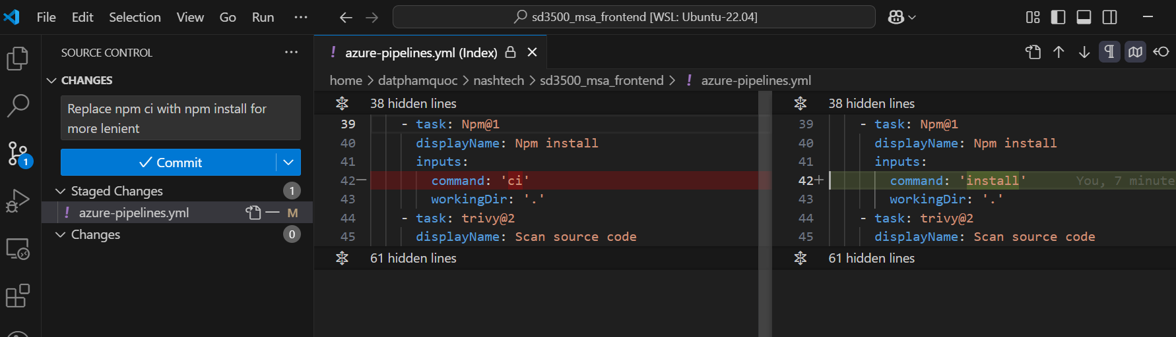

Pipeline is running

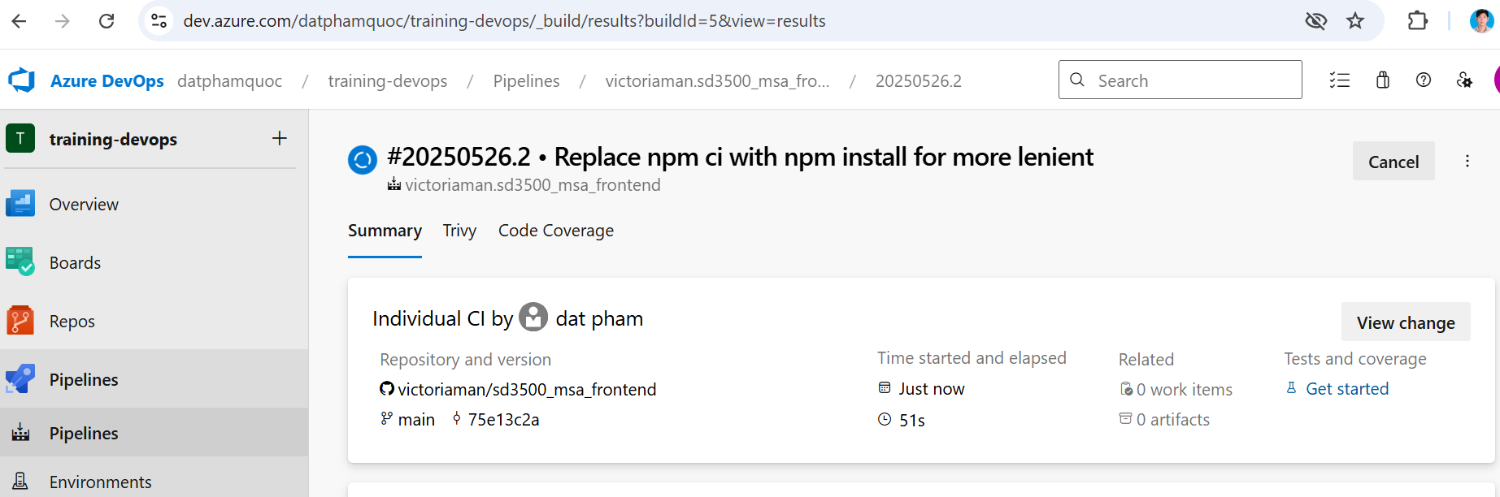

After pipeline run successfully

Trivy report

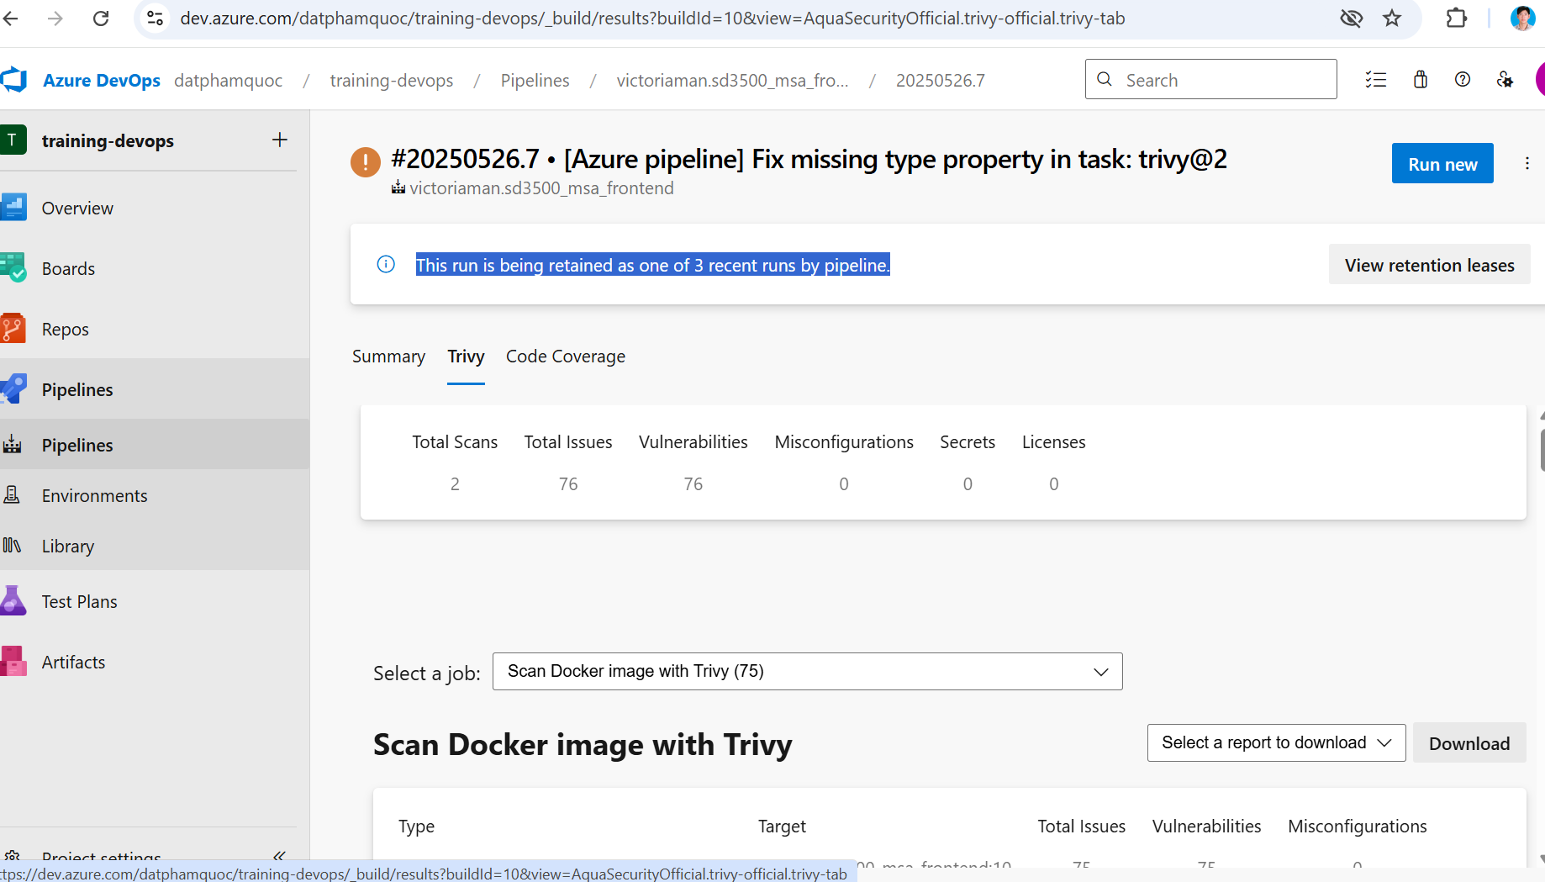

Deploy application to AKS log

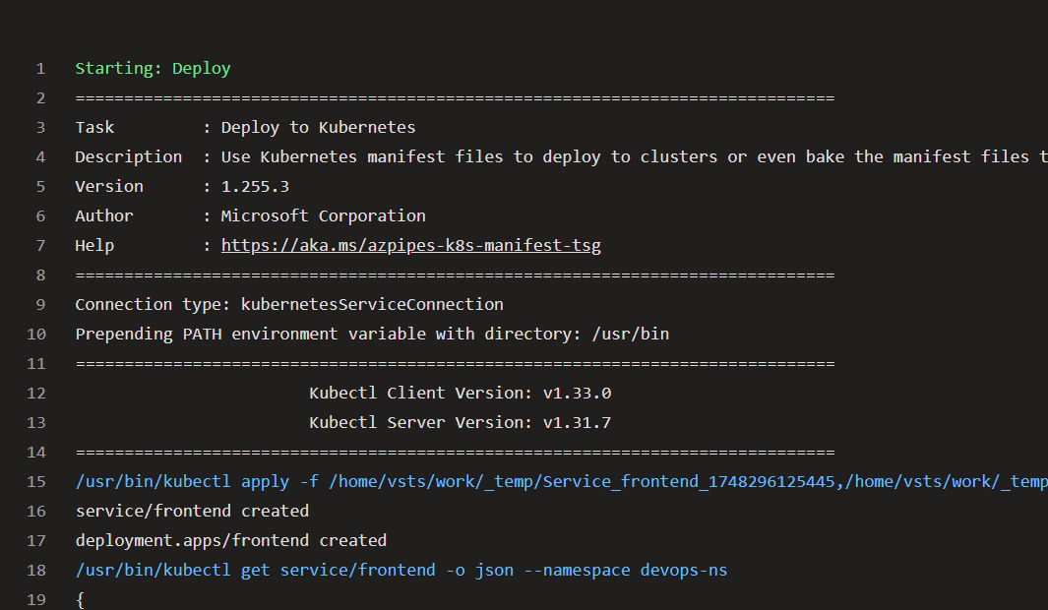

Report in Sonar cloud

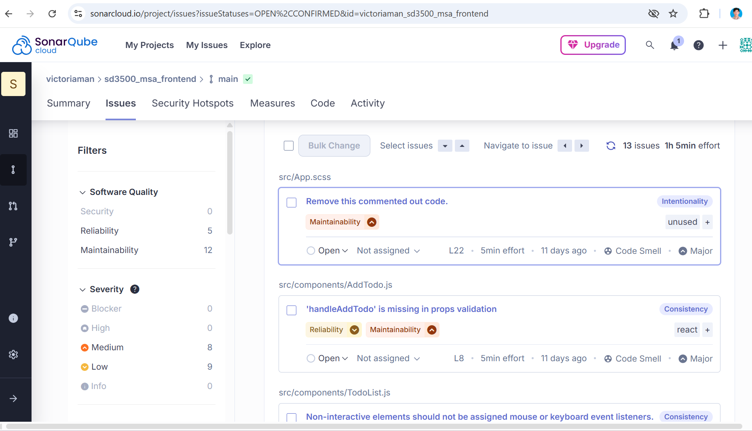

Docker image is pushed to ACR

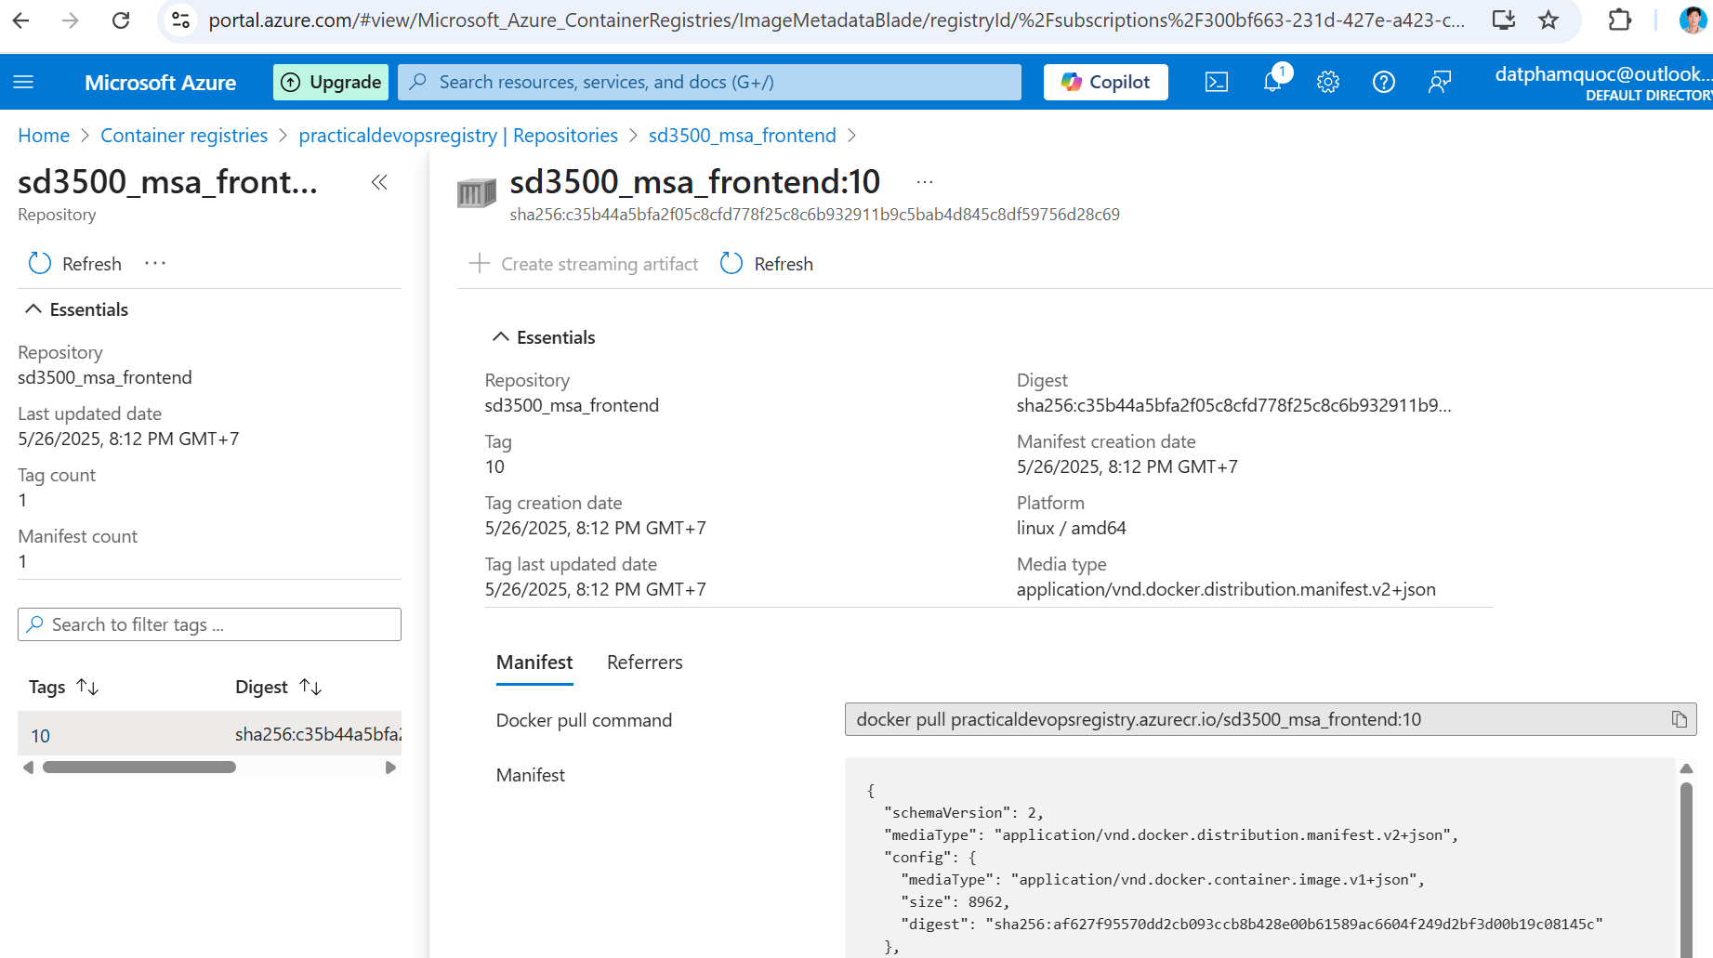

**Open terminal to check frontend service in EKS**

# Verify pod  
kubectl get pod -n devops-ns



# Verify frontend service

kubectl get service -n devops-ns



# Application verification by exposing frontend service, expose frontend service to access application

kubectl port-forward service/frontend 3000:3000 –n devops-ns

# Access to <http://localhost:3000> to verify the frontend application, which is hosted in AKS

